History and Heritage Meets Legacy & Promise:
Milwaukee’s Juneteenth Day
Join Us!

Since 1971, the Northcott Neighborhood House (NNH) has presented Milwaukee’s Annual Juneteenth Day Celebration – one of the oldest celebrations in the United States.
Join NNH as Juneteenth Day sponsor! Our event celebrates freedom, pride and culture. Reach an audience of nearly 80,000 engaged consumers of all ages.
Freedom Club – Title Sponsor, Level Amount: $15,000
- Recognition on Northcott’s Juneteenth Day website
- Inside Cover of the Juneteenth Day ad book
- Featured in signage at the event
- Booth space at the Juneteenth Day Celebration to connect with existing and new customers
- Opportunity to participate in media interviews in relation to the event
- 6 tickets to attend Miss Juneteenth pageant
Celebration Club – Sponsor Level Amount: $5,000 to $10,000
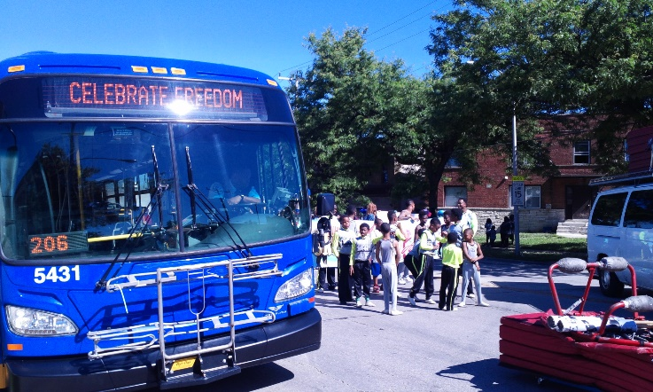
- Recognition on Northcott’s Juneteenth Day website
- Back cover of the Juneteenth Day ad book
- Featured in signage at the event
- Booth space at Juneteenth Day Celebration to connect with existing and new customers
- 4 tickets to attend Miss Juneteenth Pageant
Legacy Club- Sponsor Level Amount: $1,000 to $4,000
- Recognition on Northcott’s Juneteenth Day website
- Full page ad in the Juneteenth Day ad book
- Featured in signage at the event
- 2 tickets to attend Miss Juneteenth Pageant
Liberty Club – Sponsor Level Amount: $250 to $999
- Listing in promotion on Northcott’s Juneteenth Day website
- Half Page ad in the Juneteenth Day Ad book
- 2 tickets to attend Miss Juneteenth Pageant
Heritage Hero – Sponsor Level Amount: $50 to $249
- Quarter Page ad in the Juneteenth Day Ad book

